

General Higher Education
Graduation Certificate

Photo

This is to certify that ***, male, born on April 4th, 2003, has studied in the 4-year undergraduate program of Software Engineering from September 2021 to June 2025. Upon completion of all the courses specified by the four-year undergraduate teaching programme with qualified score, he is hereby qualified for graduation.

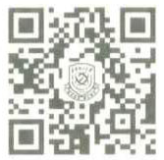

President: Xianping LUO

Date：June 30th, 2025
Certificate No.:1040512025002919
East China University of Technology

