

**Certificate of Bachelor’s Degree**

Photo

This is to certify that ***** , male, born on April 4th, 2003, has completed undergraduate curriculum in the major of Software Engineering at East China University of Technology. According to the Law of the People’s Republic of China on Academic Degrees, he is awarded the Bachelor’s Degree in Engineering.

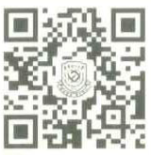

President:

**Xianping LUO**

Chairman, Degree Awarding Committee:

Certificate No.: 1040542025002919 Date: June 30th, 2025